Open Studio

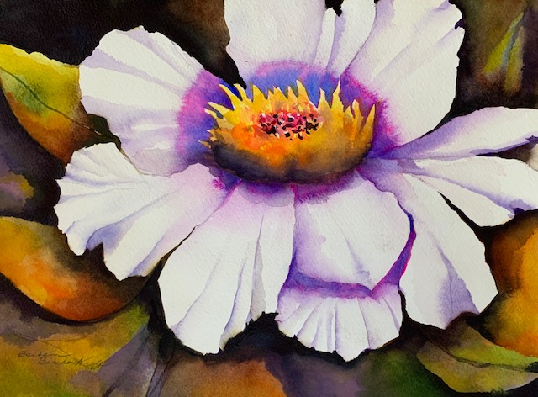
I am personally inviting you to attend a small group painting session after your workshop experience with me. Oftentimes, after a workshop, artists return home to find they may still struggle with making decisions about composition, color scheme, and design. I am offering the option of two separate group follow-up sessions at Creatively Uncorked in West Fargo on Wednesday, February 26th and Friday, February 28th from 1:00-4:00. During this time, I will offer individual assistance and advice on how to make your work stronger.
Everyone will bring their own art supplies and doors will open at 12:45. There will be no formal instruction, although I may do some mini-lessons if I see a common concern regarding painting technique or design strategy. Each session will be limited to 8 people. Bring any works in progress or paintings that are in the planning stage. Bring only the supplies you will need for the 3-hour session.

Time: 1:00-4:00 pm
Date: Choose Wednesday, February 26th __________
or Friday, February 28th __________ (you can choose both dates)

Location : Creatively Uncorked, 715 13th Ave E, Ste 101, West Fargo, ND 58078
Cost: $60 per person
To reserve your spot, please make checks payable to Barbara Benda Nagle and send to:
Barbara Benda Nagle
809 20th Street North
Moorhead, MN 56560
_ _ _ _ _ _ _ _ _ _ _ _ _ _ _ _ _ _ _ _ _ _ _ _ _ _ _ _ _ __ _ _ _ _ _ _ _ _ _ _ _ _ _ __ _ _ _ _ _ _ _ _ _ _ _ _ _ _
Yes! I want to register Open Studio with Barbara at Creatively Uncorked on Wednesday, February 26th_________________or Friday, February 28th___________
Please print clearly.
Name: _______________________________________________________________________________

Address: _____________________________________________________________________________

Preferred Phone: ___________________________________________________________________

Email address: ______________________________________________________________________
Cost : $60 per session Check #____________
PLEASE MAKE A COPY OF THIS FOR YOUR RECORDS. www.barbarabendanagle.com

